## **RESUME**

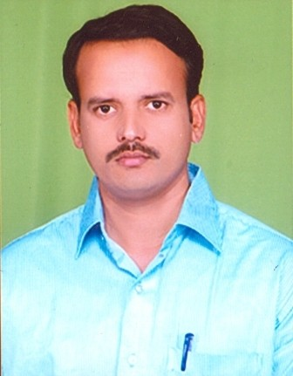

**Name: D UMAR SHARIF**

**Email:** [**umarsharif.1234@gmail.com**](mailto:umarsharif.1234@gmail.com)

**Mobile: +91-9441950196**

## **Address for communication:**

## D.NO: 6/1026,mastanpet,Guntakal, Anantapur (Dist)

Andhra Pradesh (S).

**Career Objective:**

To get an opportunity to work with an esteemed organization and become an asset to the organization by contributing meaningfully to its progress through a process of constant value and skill enhancement.

**Educational Qualifications:**

|  |  |  |  |
| --- | --- | --- | --- |
| **QULIFICATION** | **ACADIMIC YEAR** | **INSTITUTION** | **PERCENTAGE** |
| **P.hd** | 2019 | **Monad University, Uttarpradesh** | Pursuing |
| **M.Phil** | 2007 | **Annamalai University, Chidambaram.** | 58% |
| **Master of Science** | 2000 | Sri Krishnadevaraya University, Anantapur | 61% |
| **B.Sc (MPE)** | 1997 | Sri Krishnadevaraya University, Anantapur | 61% |

**Computer Skills:**

* **Computer fundamentals:** Computer hardware& software, MS-Office.

**Other Skills:**

* Self-motivated and self-starter and extremely hard working.
* Positive Thinker and a Quick Learner.
* An excellent team player, approachable, and adaptable.

**Experience:**

* I have 23 years of teaching experience in physics.

**Personal Profile:**

Name **: D UMAR SHARIF**

Father’s Name **:** D ABDUL RAHEM

Date of Birth **:** 06-06-1975

Gender **:** Male

Nationality **:** Indian

Languages Known **:** English, Hindi and Telugu

I hereby declare that all the above furnished information is true to the best of my

Knowledge.

Place: Rayadurg

Date:

(D UMAR SHARIF)